Session -1
Question 1. Write a short paragraph in your own words defining what a 'program' is and give one real-life example from any app you use daily (like Instagram, Zomato, or Paytm).
- A program is a set of instructions written in a programming language that tells a computer or mobile device what tasks to perform. Programs help users complete specific activities such as sending messages, making payments, ordering food, or sharing photos. They are designed to solve problems and make tasks easier and faster.
Question 2. List three popular programming languages you have heard of, and for each, mention whether it is usually compiled, interpreted, or can be both.
- C – A compiled language used for system and application programming.
- Python – An interpreted language known for its simple syntax and ease of use.
- Java – Uses both compilation and interpretation, making it portable across different platforms.

Question 3. Draw a flowchart (on paper or using any online tool) for the process of booking a movie ticket on BookMyShow, starting from opening the app to receiving the booking confirmation.
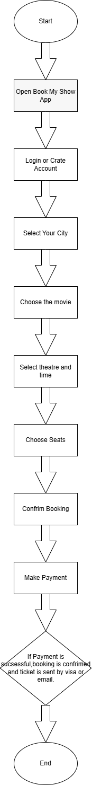

- Start.
- Open BookMyShow app/website.
- Login or create an account.
- Select your city.
- Choose the movie.
- Select theatre and show time.
- Choose seats.
- Confirm booking details.
- Make payment.
- If payment is successful, booking is confirmed and ticket is sent via SMS/email.
- End.
Question 4. Write down the steps (as an algorithm, using simple numbered instructions) for ordering food on Swiggy — from opening the app to completing payment.
- Start.
- Open the Swiggy app on your mobile phone.
- Log in or sign up if required.
- Enter or confirm your delivery address.
- Search for a restaurant or food item.
- Select the desired restaurant.
- Browse the menu.
- Choose the food items you want to order.
- Add the selected items to the cart.
- Review the items in the cart.
- Click on Proceed to Checkout.
- Verify the delivery address and order details.
- Select a payment method (UPI, Card, Net Banking, Wallet, or Cash on Delivery).
- Complete the payment process.
- Wait for the payment confirmation.
- Order is successfully placed.
- Track the order status in the app.
- End.

